**Detailed dataset information sheet**

|  |  |
| --- | --- |
| **Information Objective** | Roads and Transport Hubs |
| **Data Products** | Bunnings Retail Sites and Trade Distribution Centres |
| **Information Source / Model Product** | [Bunnings corporate website](https://l.bunnings.com.au/trade/our-locations.aspx), Google Maps, Earth and Search Engine |
| **Product Completion Progress** | Bunnings retail sites complete 28/06/18  Bunnings Trade/distribution sites complete 28/06/18 |
| **Dataset / Metadata Document** | Australia – Bunnings Locations GDB  AUS-TradeCenterAll.shp  Bunnings Locations Metadata.pdf |
| **Dataset Use** | Surveillance Strategy and Design, Pathway risk analysis |
| **Date Created/Revised** | 21/06/18 v 1.0  29/06/18 v 1.1 update |

**Background**

A national point feature spatial dataset layer identifying retail sites and trade distribution centres for Bunnings is currently being developed utilising publicly available information from Bunning’s corporate website, Google Earth, Google Maps and associated search engine.

The initial facilities for these corporate entities were identified from their corporate websites. Bunnings has two location pages, one for [retail sites](https://www.bunnings.com.au/stores) and the other for [trade distribution centres](https://l.bunnings.com.au/trade/our-locations.aspx).

**Initial Dataset Procurement Process**

The dataset has been derived by a number of manual processes:

* The list of Bunnings retail sites for Australia was sourced from their corporate website and manually geo-coded by extracting GPS coordinate values by visually inspecting and then mapping these sites using Google Maps and Google Earth (Figure 1)
* The polygon areas of the Bunnings sites was also digitised in this process
* The KML file from Google Earth was imported into ESRI’s ArcMap and converted using the KML to Layer tool
* In the course of initially locating and visually confirming each retail site, some trade distribution centre locations were spotted and this data was captured (figure 2)

Figure 1. Google Earth view of Bunnings retail sites in the Australian Capital Territory

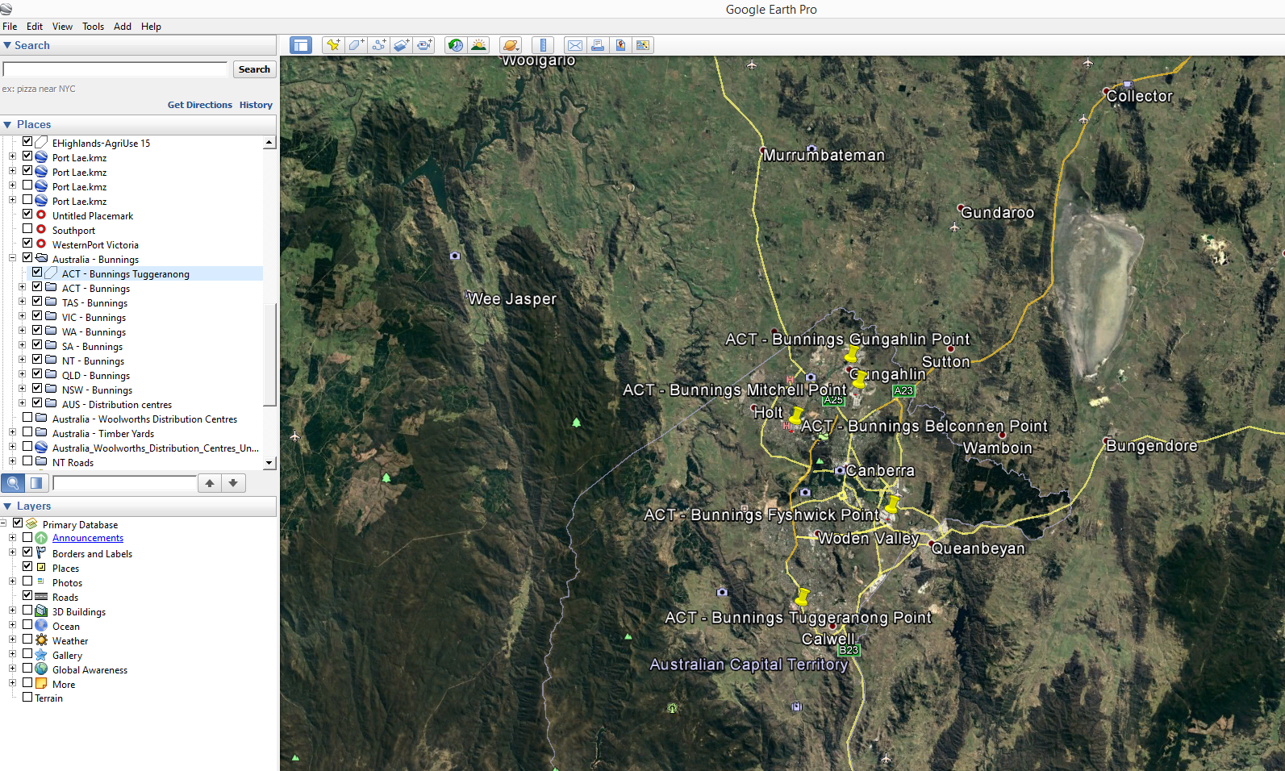

Figure 2. Google Earth view of a Bunnings Trade Distribution centre site in Windsor Gardens, South Australia

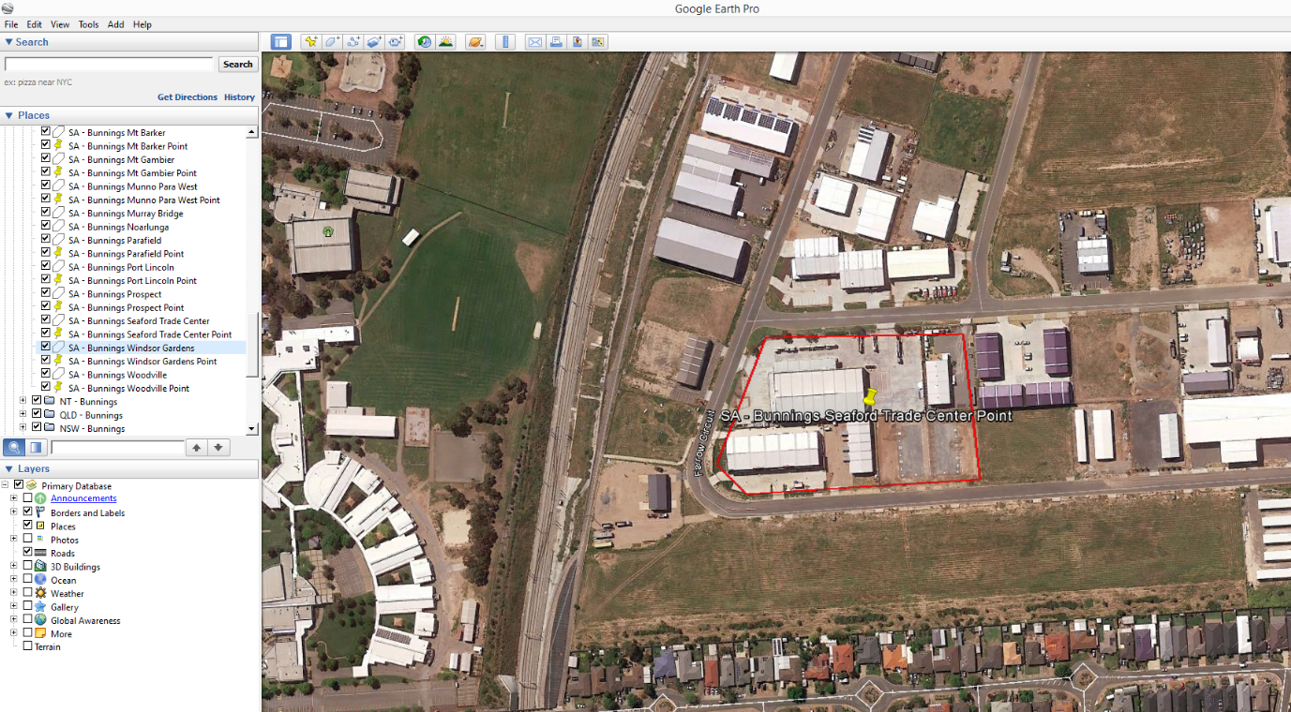

**Secondary Dataset Procurement Processes**

Following this initial data compilation, the Trade Distribution Centres have also been mapped and added to the existing layer.

This was accomplished by following the process described in the initial dataset procurement section.

The data attribute table for the Trade Centres layer were updated to include the SharedRet (co-located with Retail sites Yes or No), State, Suburb, Postcode_1, Lat and Long fields listed in the screenshot below:

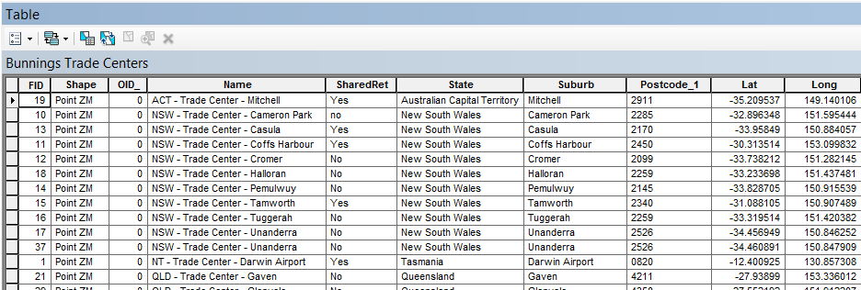

The data attribute table for the Retail sites layer were updated to include the State, Suburb, Postcode, Lat and Long fields listed in the screenshot below:

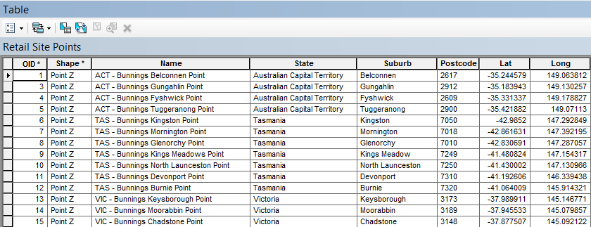

**Limitations**

* None considered at this stage of the procurement

**Quality Check**

* Some Trade Centre sites appear to be co-located with Retail sites
* Two of these Trade Centre features have been removed from the Retail Sites layer as they were picked up in the initial process
* Bunnings lists store name headings by suburb
* They also list the full postal address for each suburb
* Some of the suburb headings conflicted with the actual suburb/postcode location information
* This information was captured into separate fields
* The Retail site features were also quality checked by the same method

Table 1. Summary of the datasets and their completion status to date

|  |  |  |  |  |
| --- | --- | --- | --- | --- |
|  | **Initial feature Count** | **Additional features detected using online sources** | **Estimated number of distribution centre features to be captured** | **Total feature count of completed dataset** |
| **Bunnings Australia – Retail Sites** | **288** | **-2** | **-2** | **286** |
| **Bunnings Australia – Trade Centres** | **0** | **38** | **38** | **38** |

Discussion and Future Work

Future work may include quality assurance checks to confirm co-location of Retail and Trade Centre sites and ensure facilities identified are still operating.

Calculation of useful feature attributes such as:

* Area of shaded nursery sections of Bunnings sites
* Quantity of plant seedlings contained within each Bunnings Site
* Proximity in kilometres to major freight hubs, AA ports of entry and community gardens

Project Resources Estimates and Uses

An estimate of the timeframes and data procurement requirements required to complete this dataset is summarised in Table 2.

The end result will be a dataset product which is of a High to Authoritative quality and can be referenced as a point of truth data source for input into projects such as surveillance strategy and design.

This dataset will provide accurate and useful information such as:

* Bunnings retail sites and trade distribution centres
* Ownership and Contact information
* Area sizes
* Plant seedling quantities per Bunnings site

And will assist in:

* Serving as an input in estimating labour and capital resources for conducting surveys for pests such as those in the National Priority Plant Pests (NPPP) target groups, e.g. number of field officers required to inspect a given quantity of plant seedlings over a specified amount of time
* Mapping requirements for national/state emergency response programs that are deployed when these pest incursions occur
* Providing a feed-in data layer alongside the national road network for determining distribution pathways and the risk levels of these pathways

Table 2. Comparison of process methods and output dataset quality expectations

|  |  |  |  |  |
| --- | --- | --- | --- | --- |
| **Process** | **Requires Industry Assistance** | **Requires State Government Assistance** | **Estimated time to complete** | **Expected Dataset Quality Level** |
| Bunnings | Possibly – for quality checking operational status and ownership details of identified facilities | No | ~ 1 week  Completed 28/06/18 | High to Authoritative |